**Alekhya Krishna Balivada Python Day 2 Assessment-2(13-12-2023)**

**Conditional Statements:** Conditional statements are fundamental programming constructs that allow you to control the flow of your program based on conditions that you specify.

Types of conditional statement: 1. If statement

2. If-else statement

3. If-elif-else statement

4. Nested if statement

1. **If Statement :** If the condition mentioned in the if block is true then the code of the block executes otherwise not.

**Syntax :** if (condition):

Print( )

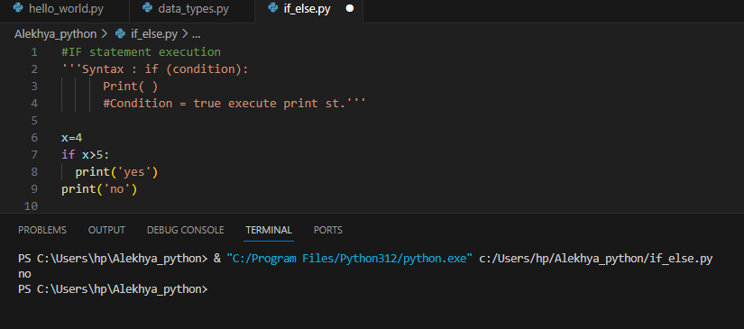 Condition = true execute print st.

1. **If-Else Statement:** If the condition is true executes the if block otherwise executes the else block.

**Syntax:** if condition :

**#** executes if block if the condition is true

Else:

# executes else block if the condition is false

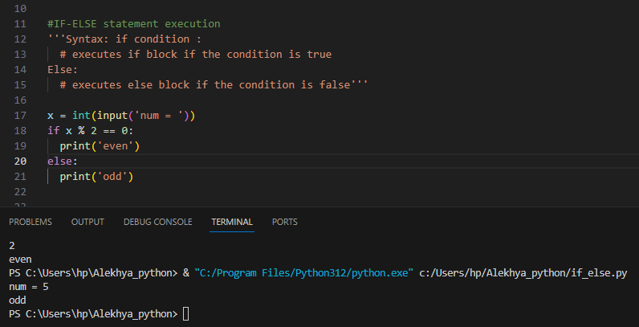

1. **If-elif-else statement:**

Syntax : if condition 1 :

# code block-1

Elif condition 2:

# code block-2

Else :

# code block-3

* If condition 1 is true then if block is executed
* If condition 1 is false and condition 2 is true then elif block is executed
* If both condition 1 and condition 2 are false then else block id executed

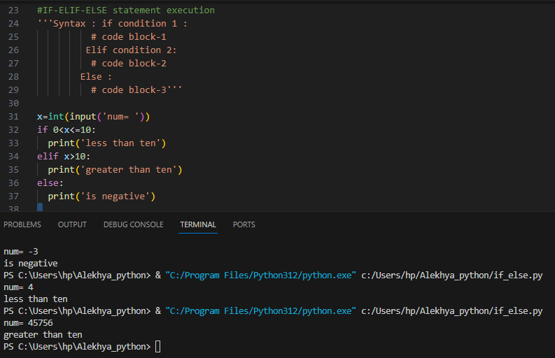

1. **Nested if statement:** use an if statement inside of an if statement. This is known as a **nested if** statement.

**Syntax:** if condition 1:

**#** code block **–** 1

if condition 2 :

# code block – 2

Else :

# code block – 3

Else :

# code block – 4

* If condition 1 & 2 are true then code block 1 , 2 are executed
* If Condition 1 is true but condition 2 is false then code blocks 1, 3 are executed
* 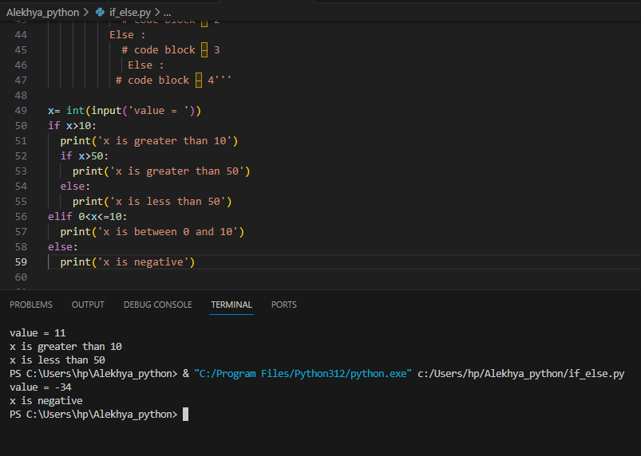If condition 1 is false the code block 4 is executed

**LOOPS**

**Loops:** Loops instructions that continually repeat until a certain condition is reached.

1. **While loop:** A control statement which allows code to be executed repeatedly depending on whether a condition is satisfied or not.

**Syntax:** while condition:

#statements

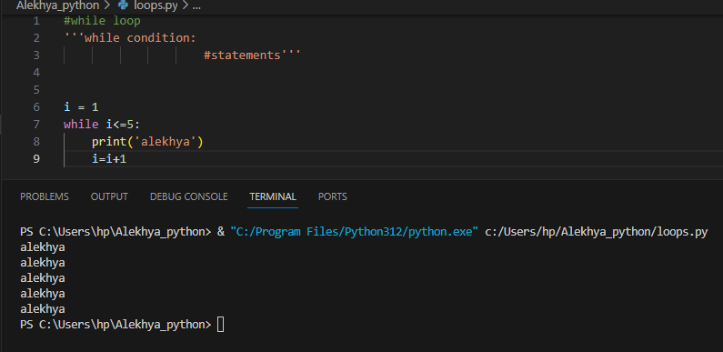

1. **For loop :** For loop is a control flow statement that is used to repeatedly execute a group of statements as long as the condition is satisfied

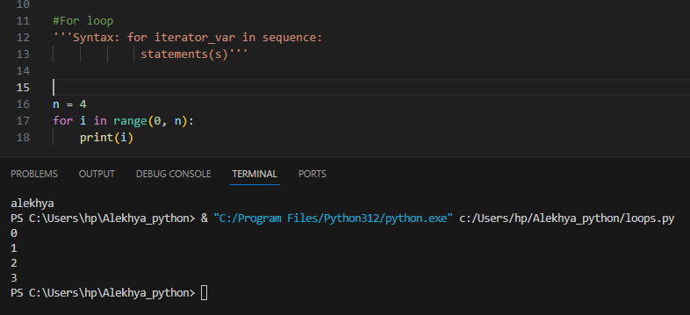**Syntax:** for iterator_var in sequence:  
    statements(s)